

**CcpNmr AnalysisScreen**

**Tutorials**

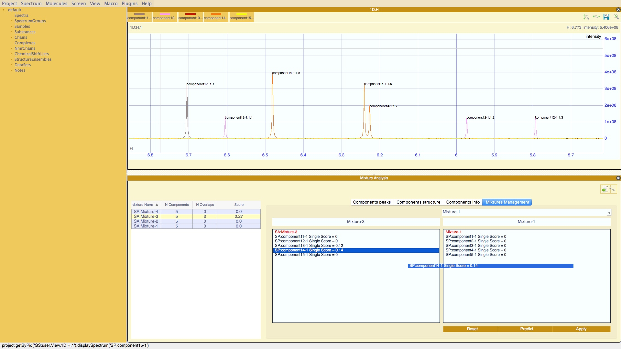

**[](http://www.ccpn.ac.uk/)[](https://twitter.com/ccpnmr)**

# Table of Contents

Table of Contents 2

Introduction 3

Excel Lookup File 4

SpectrumGroups, Samples, Substances 12

1D Peak Picking 19

Mixture calculation 24

Pipeline 30

Hit Analysis Module Error! Bookmark not defined.

# Introduction

In these tutorials you will learn how to:

* prepare an Excel file to load all your metadata;
* manually create SpectrumGroups, Samples, Substances and edit them;
* peak picking of One-Dimensional spectra;
* create and analyse mixtures;
* use the pipeline;
* find and inspect spectrum hits

Before you start, it is important that you have a minimal knowledge of how CcpNmr Analysis V3 works and you have completed the Introductory tutorial.

The first two tutorials are generic “How Tos” and independent from the rest of tutorials. You might want to skip them, you will find pre-filled Excel files across the tutorials.

You can find One-Dimensional Spectra on: *Data/testProjects/AnalysisScreen_Demo1*

To start the program:

On Mac: double click the Screen Icon or the file Screen on the bin directory

On the Virtual Machine: type screen on the terminal

NB. These tutorials contain randomly generated data that don’t’ have biological significance. All spectra showed are synthetic and for demonstration purposes only. All compound names are randomly chosen and might have incorrect chemical properties or not represent the linked spectra.

# Excel Lookup File

In this section you will learn how to create an Excel file to automatically load all your spectra and metadata into the program.

Using a lookup file you can easily create CcpNmr objects which, once loaded, will be immediately available in the Sidebar.

The program can read .xls or .xlxs files with multiple sheets that include the words ‘Sample’ or ‘Substance’ in the sheet name (Figure 1).

You can create files that contain either the Substance or Sample page or both.

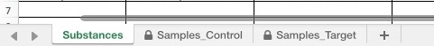

Figure 1 *Lookup. Sheet names example.*

### Substance page

The first sheet (Figure 2), Substance, can contain metadata associated with small molecules in which spectra have been used as references for a screening trial.

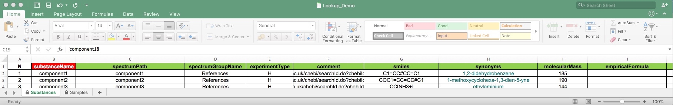

Figure 2. *Lookup template. Substance Sheet*

1. Open the directory containing your spectra files.

For this example, we will use the spectra located in *AnalysisV3 / data / testProjects / AnalysisScreen_Demo1 / demoDataset_Lookup.*

These are called component1-component20.

1. Copy and paste the lookup template into the same directory as your spectra;

You can find a template in the /tutorials directory or download it from ccpn.com.

1. Open the template and start to fill the column. The only mandatory column to fill is the *substanceName*.
2. On a Mac machine, a quick way to fill the table is to multi select the directory or spectra files you want to include, then copy and paste on the excel cell under *substanceName*.

Let’s select the first five components.

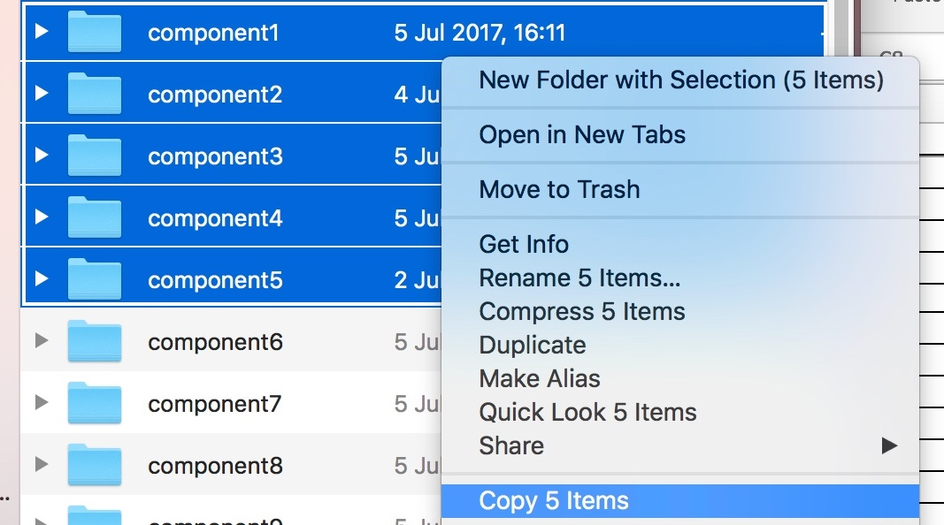

Figure 3

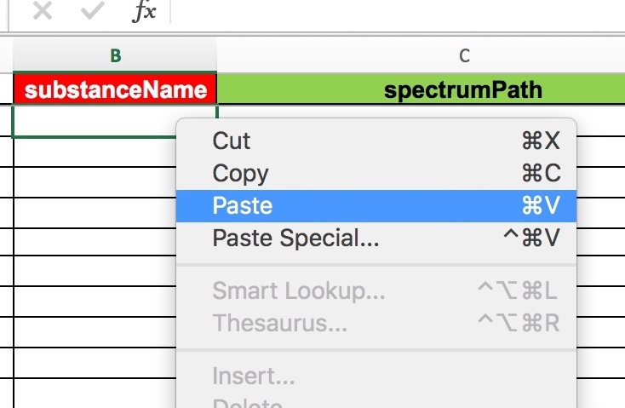

Figure 4

Or copy and paste the names:

component1

component2

component3

component4

component5

1. To include the Substance reference spectra, you need to insert the path. You have three options:
   1. If all the spectra files are located in the same directory of the lookup, insert only the file names as in the previous point. No matter what the spectrum format is, if is recognised by CcpNmr, it will be opened:

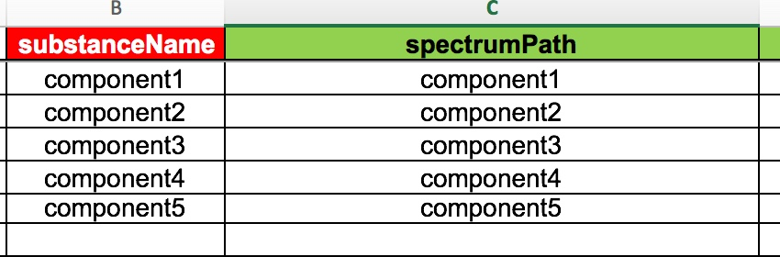

Figure 5

* 1. If the spectra are located in a subdirectory, insert the directory name first followed by a slash and the filename (the relative path starting from the excel file), e.g., references/component1
  2. If the spectra files are located in a completely different location, insert the full path, e.g., /Users/username/Desktop/data3/MySpectra/component1

For clarity, it is recommended to keep all the files in the same directory together with the lookup file.

1. Next, insert the *spectrumGroupName*; e.g., References. This will create a SpectrumGroup in the software. SpectrumGroup or SG (Pid name) is a feature of CcpNmr to group together similar spectra. SGs can be dropped into spectrum displays and are treated as single spectra. They are extremely useful, for example, for comparing different experimental conditions. Of course, you will also be able to use the spectra independently in other displays.

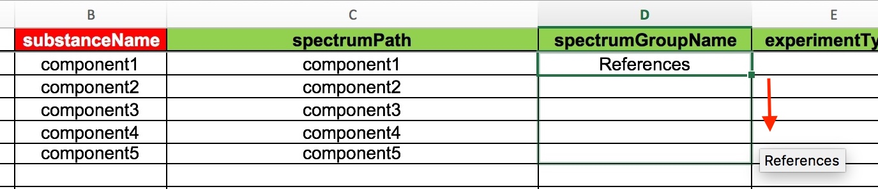

Figure 6

1. Next, fill the *experimentType* cell. The list of experiment types, their nomenclatures and more information, can be found inside the V3 documentation.

For these one dimensional spectra, simply add “H” on the excel cell.

1. The *comment* column will store any textual information about the substance.
2. If you have the *smiles* for your substances, including here will automatically generate the structures inside the software. As a demo, copy and paste these smiles:

|  |
| --- |
| C1=CC#CC=C1 |
| COC1=CC=CC#C1 |
| CC[NH3+] |
| CC(O)CC(O)=O |
| CC(O)(CCO)CC(O)=O |

On excel, click on the small folder on the bottom right of the pasted items and select*: Match Destination formatting* (Figure 7).

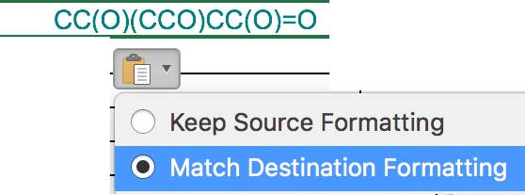

Figure 7

1. In the *synonyms* insert the chemical name of the substance and again select *Match Destination formatting*, e.g.:

1,2-didehydrobenzene

1-methoxycyclohexa-1,3-dien-5-yne

ethylaminium

3-hydroxybutyric acid

mevalonic acid

1. All the following columns are simply the substance chemical properties. Fill them if you want to display them within the software.
2. Save the file.

A complete lookup for the Substances will look like Figure 2.

This file can be dropped into AnalysisV3.

### Samples page

The next sheet in the template is Samples. This can contain metadata associated with particular samples; for example, in a screening trial the sample will contain all the spectra recorded in different experimental conditions.

Unfortunately, this will create some duplication on the table. If a sample has associated five spectra, you will add five different row on the excel page, and duplicate five time the sample name. However, this solution has the main advantage to define for each spectrum whether or not you want include it in a SpectrumGroup.

Let’s create a sample page.

The only mandatory column name is the *sampleName*. You can fill the first four columns like for the Substances sheet.

1. Insert the *sampleName*: e.g. “Sample1”

The next three columns (in green colour) are specific for the spectra recorded for this sample.

1. Insert the *spectrumGroupName*:eg “STD_Target”. if you want the spectrum to be included in a spectrumGroup
2. Insert the *spectrumPath*:e.g. “STDs/Sample1_Std”. (See the previous section for how to insert the spectrum path)
3. Insert the spectrum *experimentType*:e.g. “STD.H”. (See the documentation for *experimentType* nomenclature)

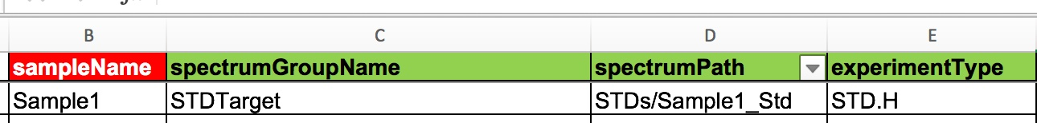

Figure 8

1. The next column is the *sampleComponents*. In this cell insert the components names that are present inside the sample. In the case of a mixture containing *component* *1* to *5*, insert as a comma-separated list without spaces:

*component1,component2,component3,component4,component5*

In CcpNmr V3, when a sampleComponent is created with exactly the same name as a Substance, the two objects are linked, including all the metadata. More about this concept can be found in the documentation.

The successive columns are simply chemical properties of the sample. Fill them if you want to display them within the software.

To add extra spectra for the same sample, repeat points 1 to 3. There is no need to duplicate the samples properties (yellow columns) as long as the sample name is the same. If you add twice the same information, only the first entry will be considered.  
To add an extra sample, simply fill the rows and columns like previously. A complete lookup for the Samples will look like (Figure 9):



Figure 9

This file can be dropped into AnalysisV3 (Figure 10):

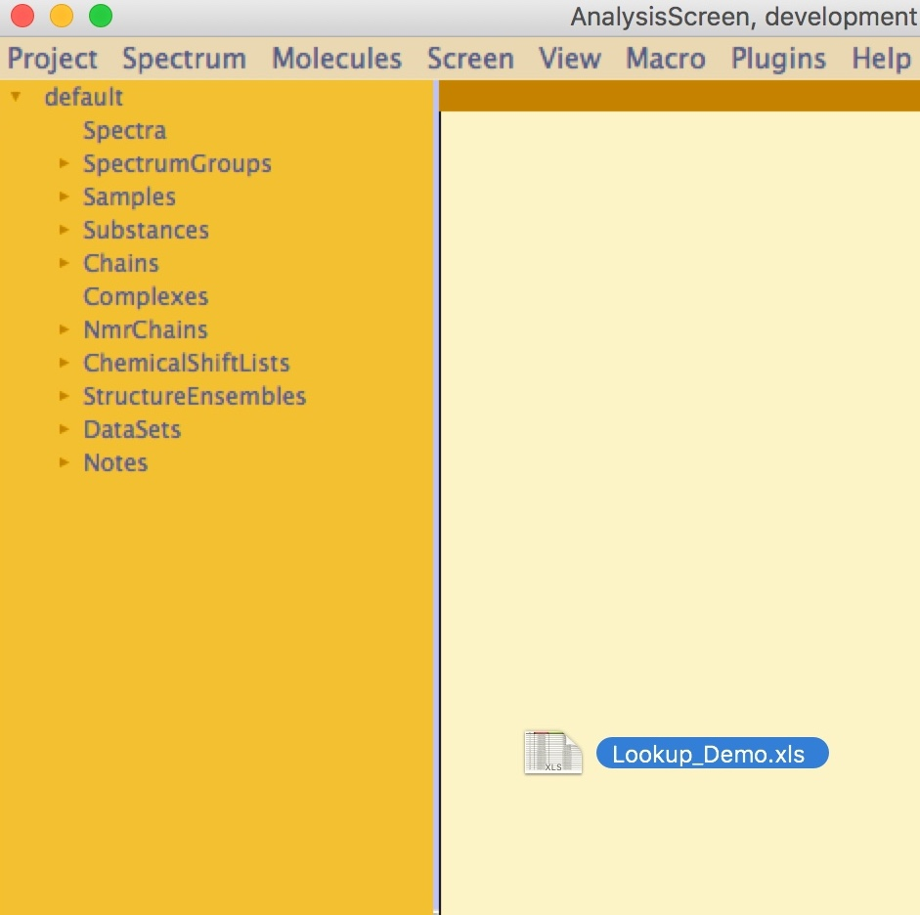

Figure 10

Once expanded, the sidebar will look like (Figure 11):

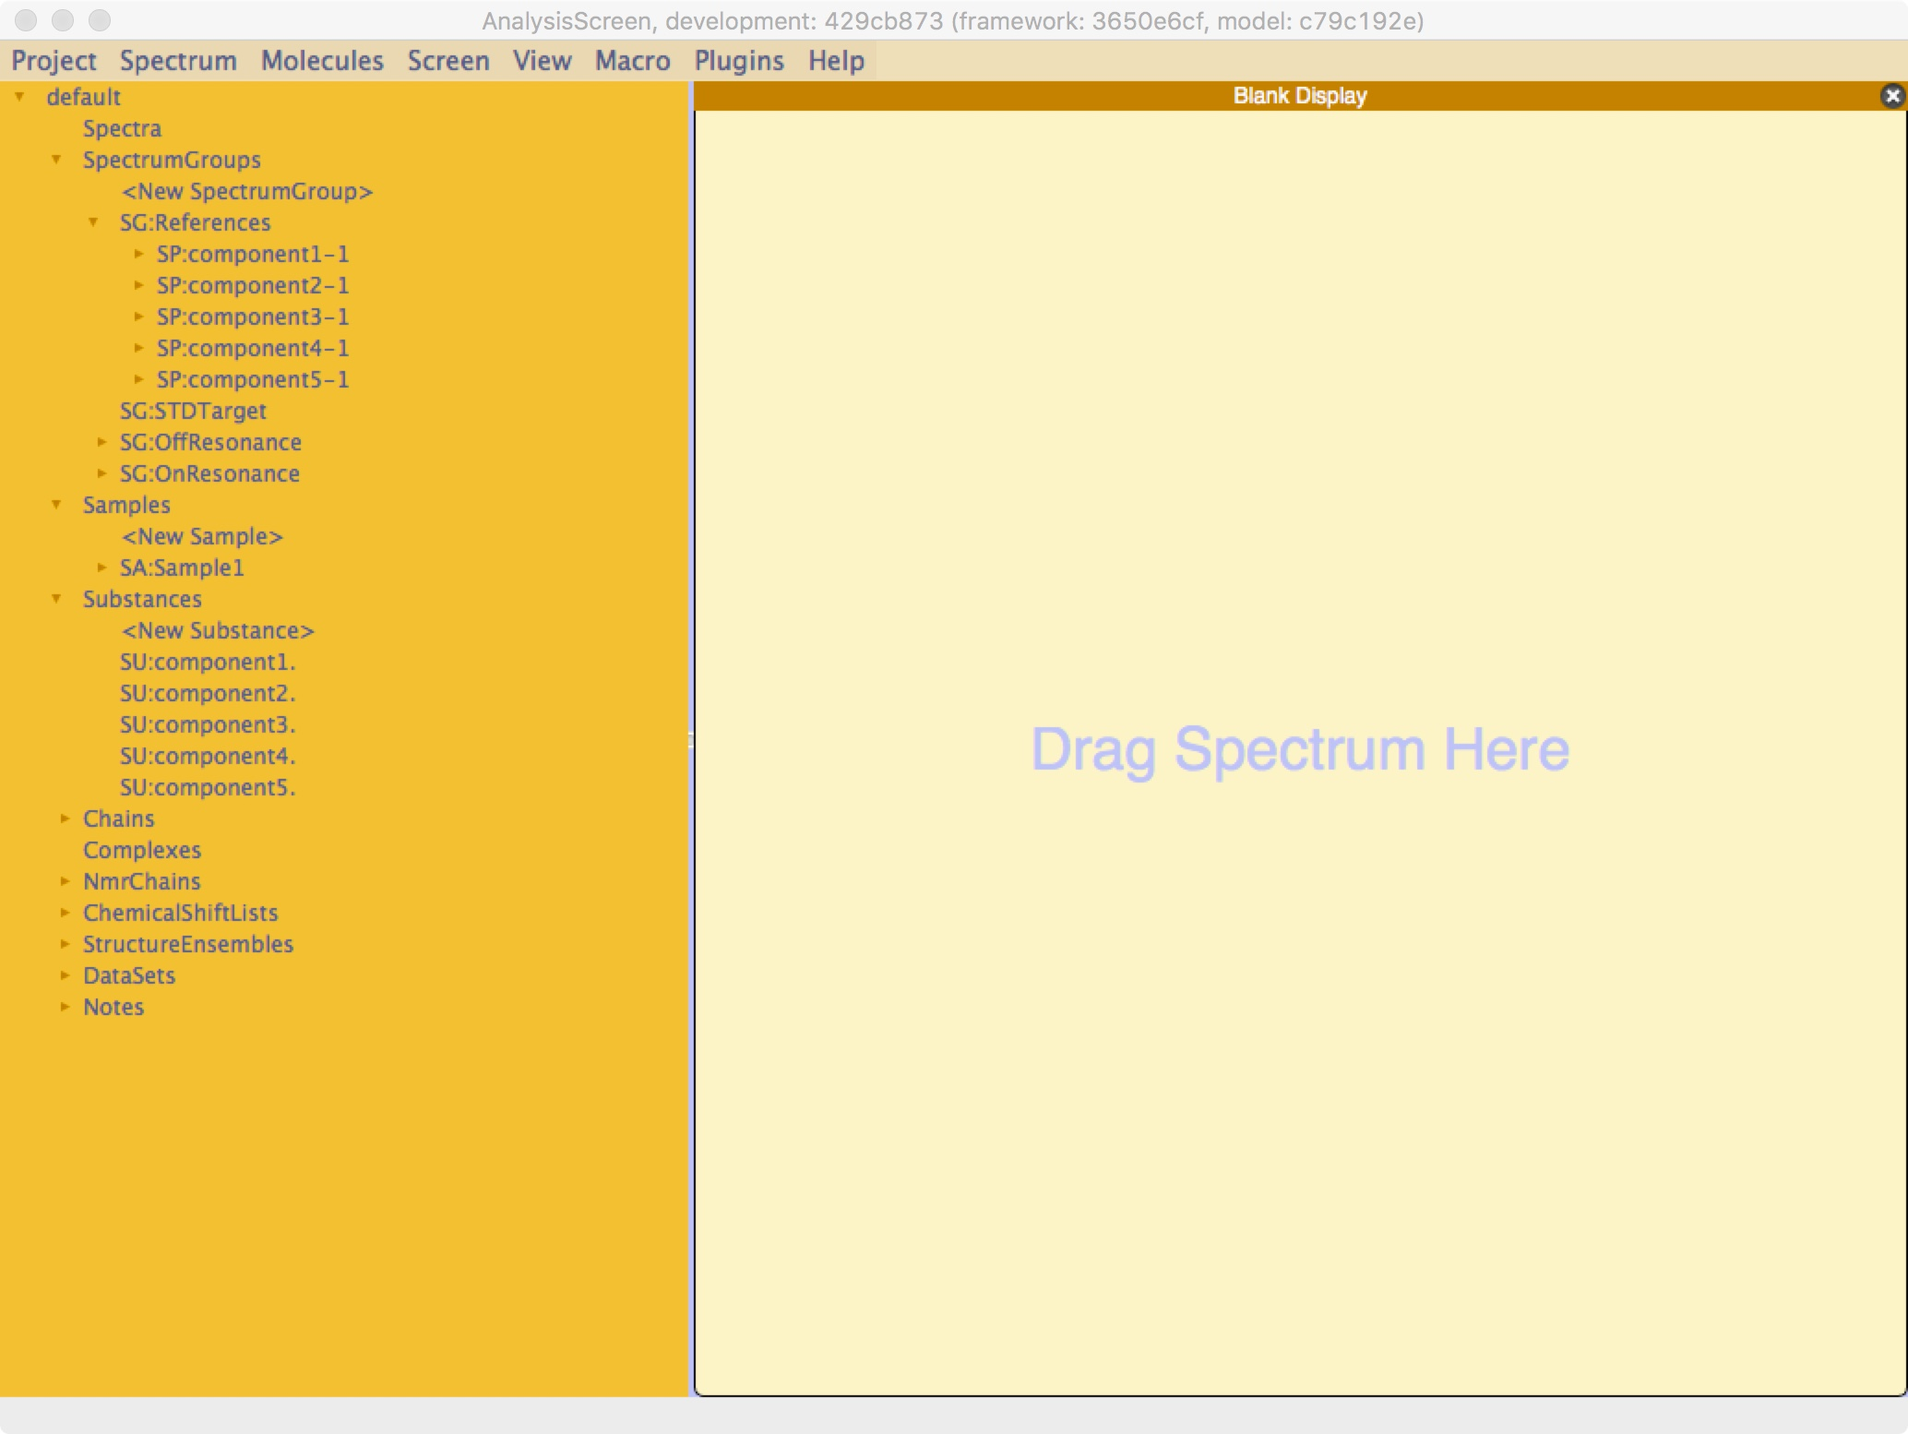

Figure 11

NB. The same lookup file containing the same values cannot be dropped twice into the same project; a new object cannot be created matching a pre-existing name. When dropping the same file twice onto a project, only the first entries will be preserved.

# SpectrumGroups, Samples, Substances

In this tutorial you will learn how to manually create SpectrumGroups, Samples, Substances.

A basic knowledge of these objects is fundamental for using AnalysisScreen, and they will be used throughout the tutorials.

### How to create a SpectrumGroup

In a new empty project:

1. Drag-and-drop some spectra into the sidebar

(You can find One-Dimensional Spectra on: Data/testProjects/AnalysisScreen_Demo1)

1. On the Sidebar, find the SpectrumGroups item:

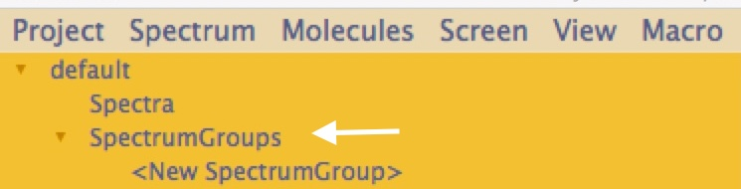

1. Expand the branch
2. Double click on <New SpectrumGroup>, a popup will open:

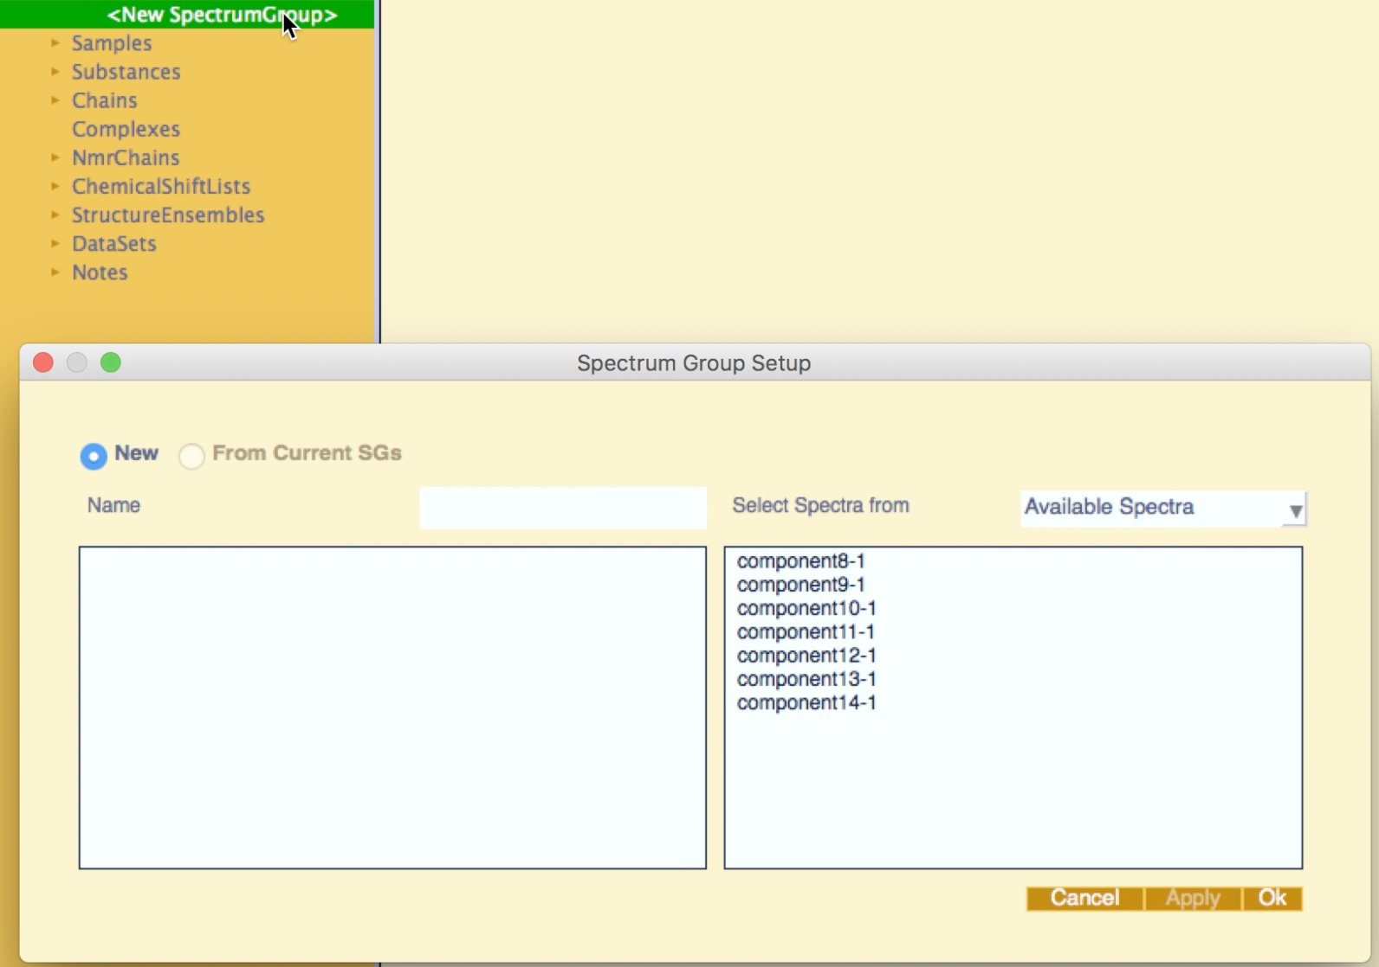

1. Insert the desired Spectrum Group name
2. Select an item in the pulldown *Select Spectra From*
3. If *Available Spectra* is selected, a list of all spectra in the project will appear in the right box
4. Simply select the desired spectra (for multiple selection: hold the Shift key):

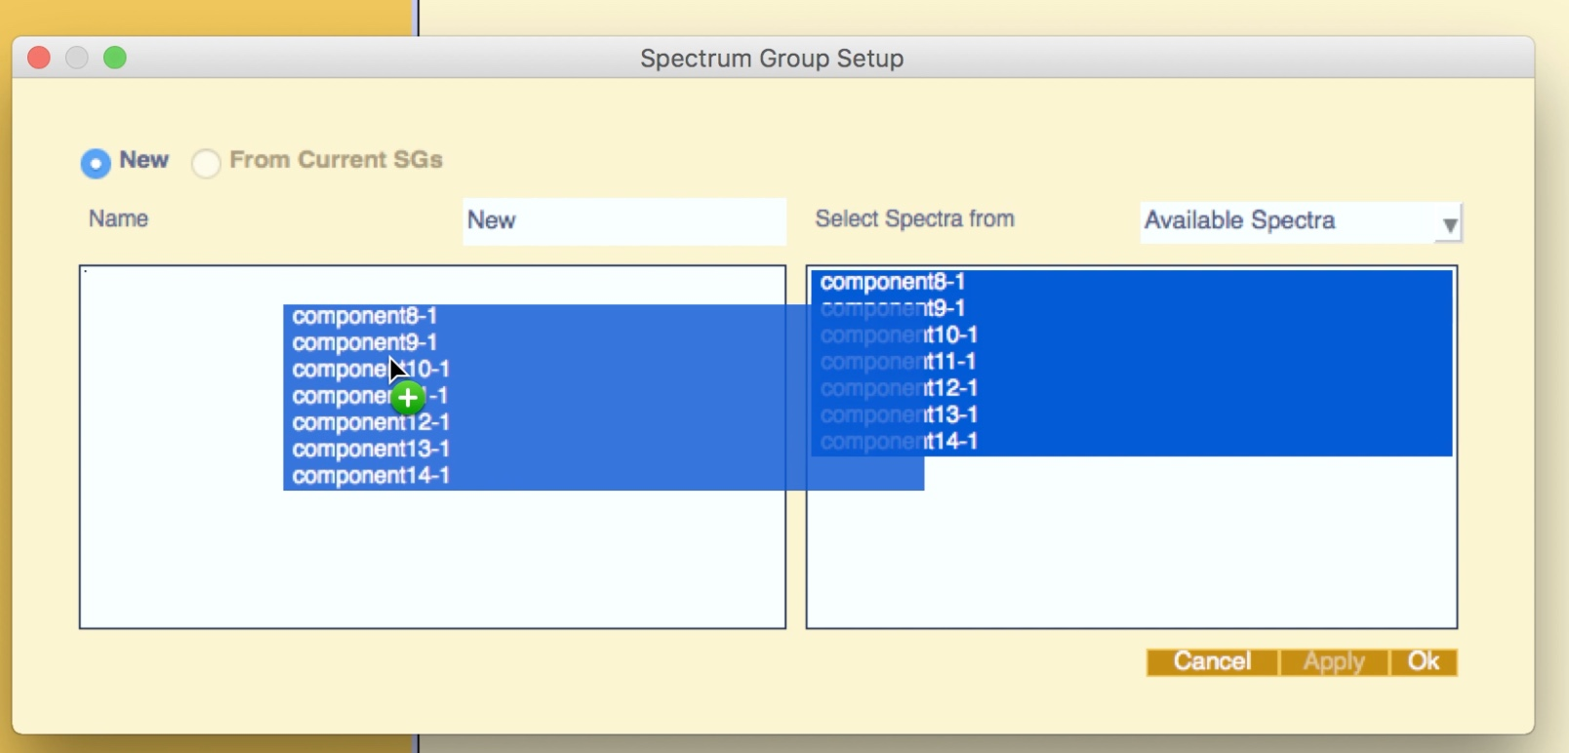

1. Drag-and-drop the items to the left box
2. Click ok

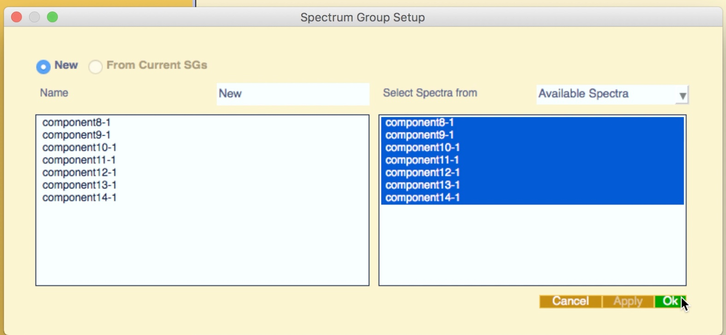

1. The new SpectrumGroup will appear in Sidebar

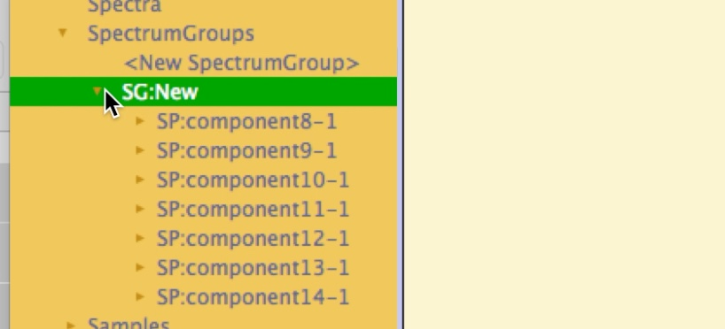

To display this SpectrumGroup, drag-and-drop it into a Blank Display

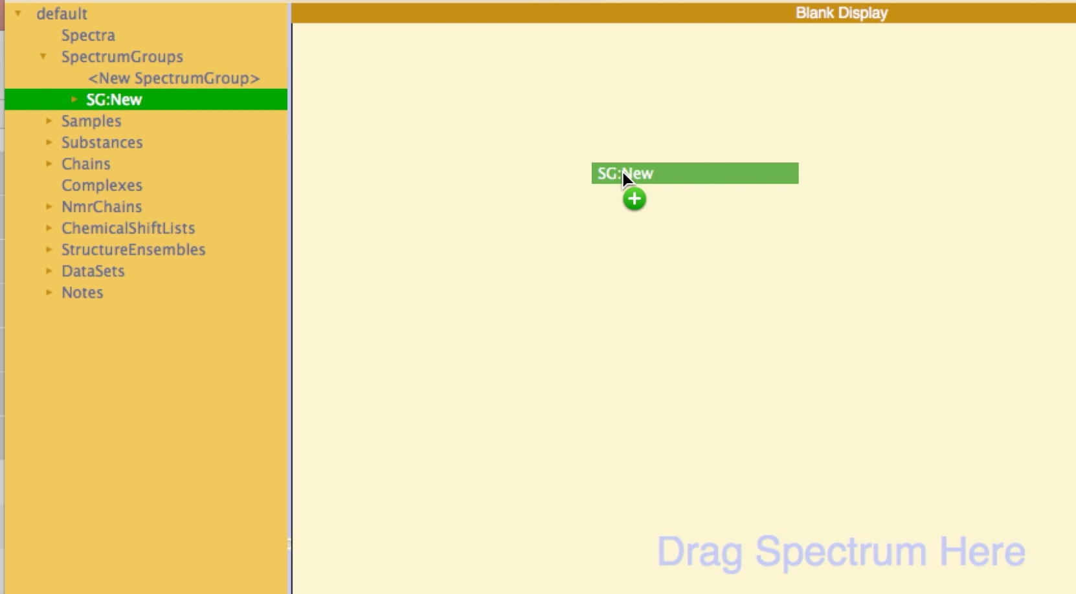

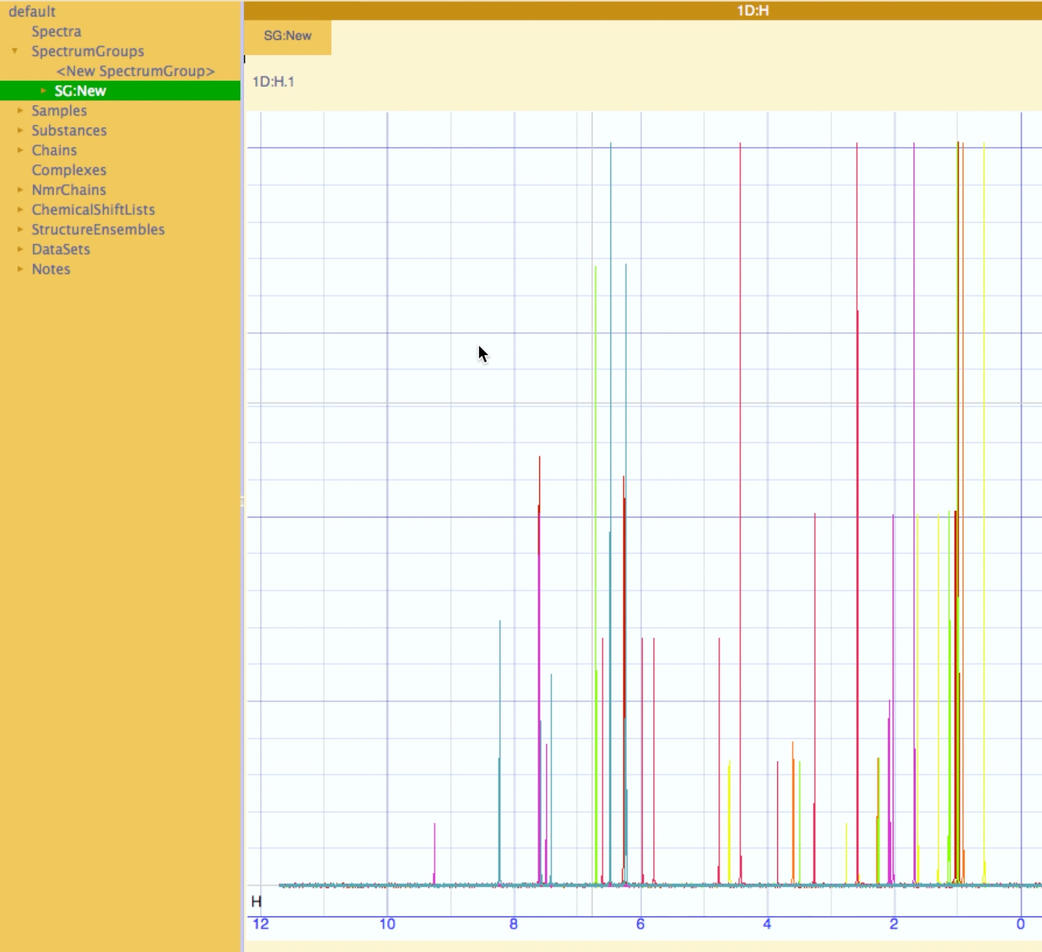

### How to create Samples

In a new empty project:

1. Drag-and-drop some spectra into the sidebar

(You can find One-Dimensional Spectra on: Data/testProjects/AnalysisScreen_Demo1)

1. On the Sidebar, find the *Samples* item
2. Expand the branch
3. Double click on <New Sample>

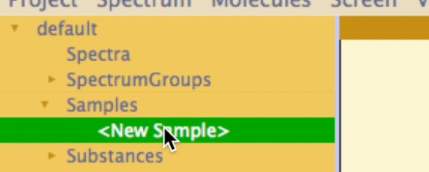

1. A default Sample will appear in the Sidebar, double click on it, a popup will open
2. Insert the name and properties as below, and click Ok

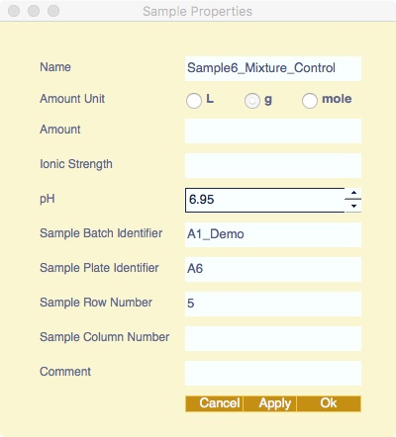

To link spectra to this sample

1. On the Sidebar, find the required items, these could be in *Spectra* or *SpectrumGroups*
2. Double click the spectrum of interest; the spectrum popup will appear.
3. Find the sample pulldown entry and select the new sample just created.

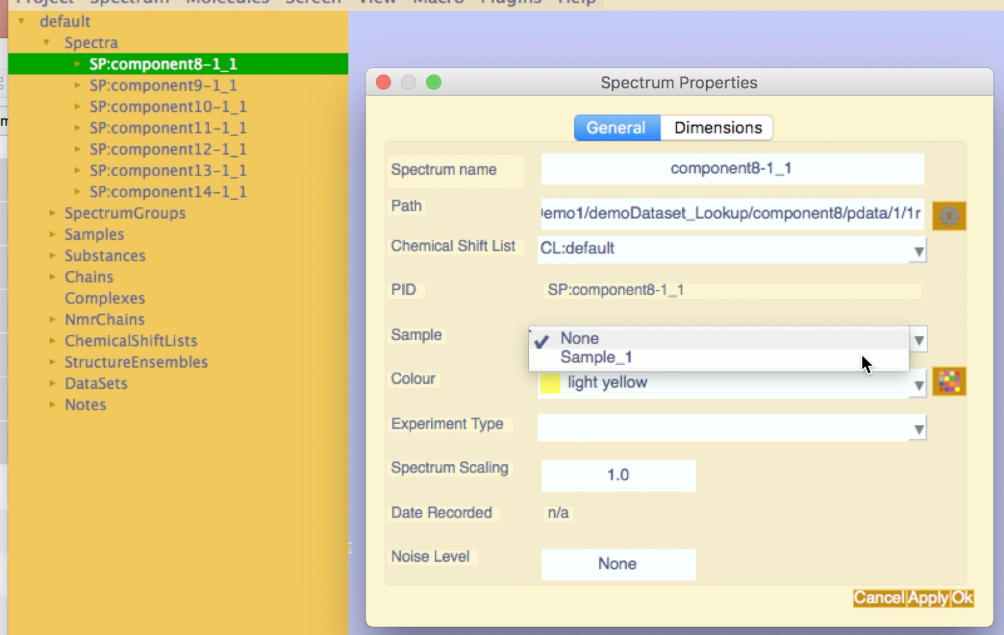

To add *sampleComponents*:

1. On Sidebar, find the sample item you want to add *SampleComponent*
2. Expand the branch
3. Double click on <New SampleComponent>, a popup will open
4. Select new on the radioButtons

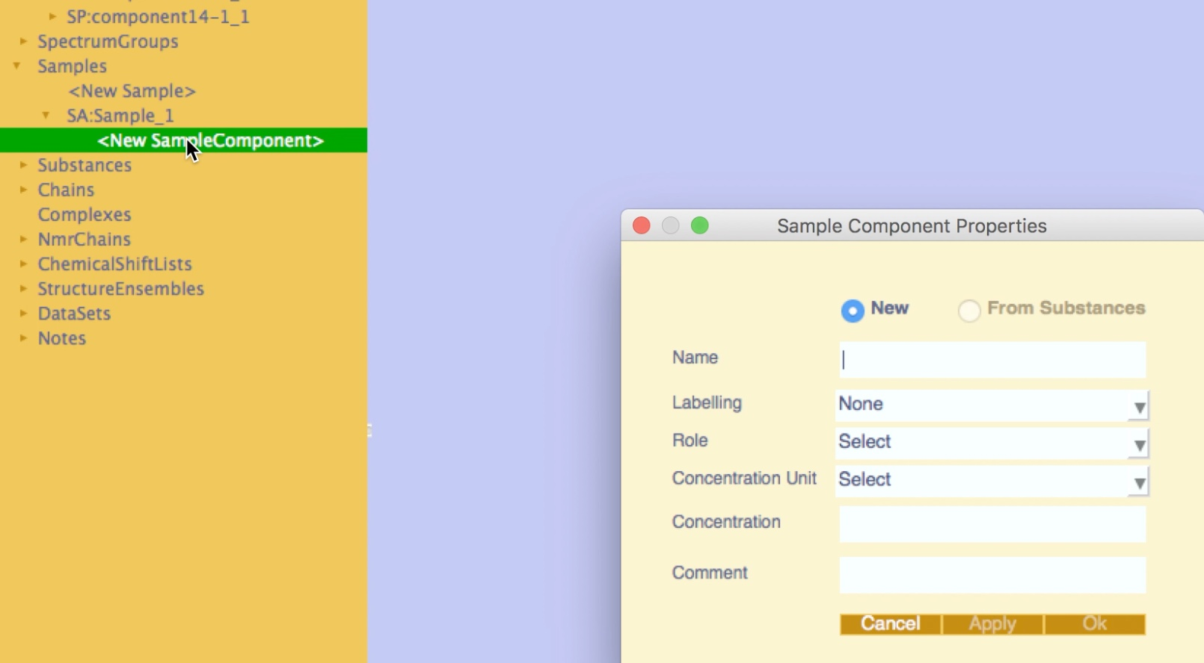

1. Insert the name and all properties
2. A new *SampleComponent and* linked *Substance* will be created

If you want to create a *SampleComponent* from a pre-existing Substance, e.g., used as a reference, select the radioButton *from Substances* and select the substance from the pulldown. This option will be available only if you have already Substances in the Project.

Errors:

* Incomplete entry (Figure 12); select from the *concentration unit* pulldown.
* *concentration* entry contains String or Integer, insert a float (e.g. 0.75)

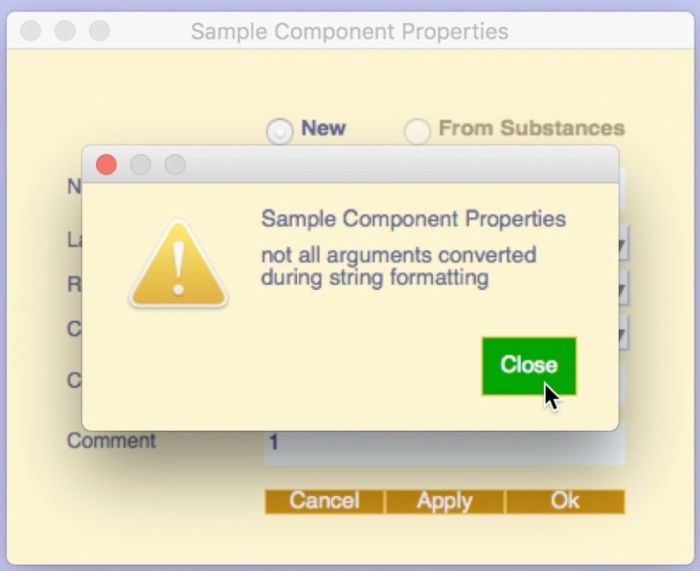

Figure 12

### How To Create Substances

In a new empty project:

1. Drag-and-drop some spectra (if you want to link them to the substances)
2. On the Sidebar, find the *Substances* item
3. Expand the branch
4. Double click on <New Substances>, a popup will open
5. Insert the name and all properties
6. Click more to extend the popup
7. Click Ok to apply and close

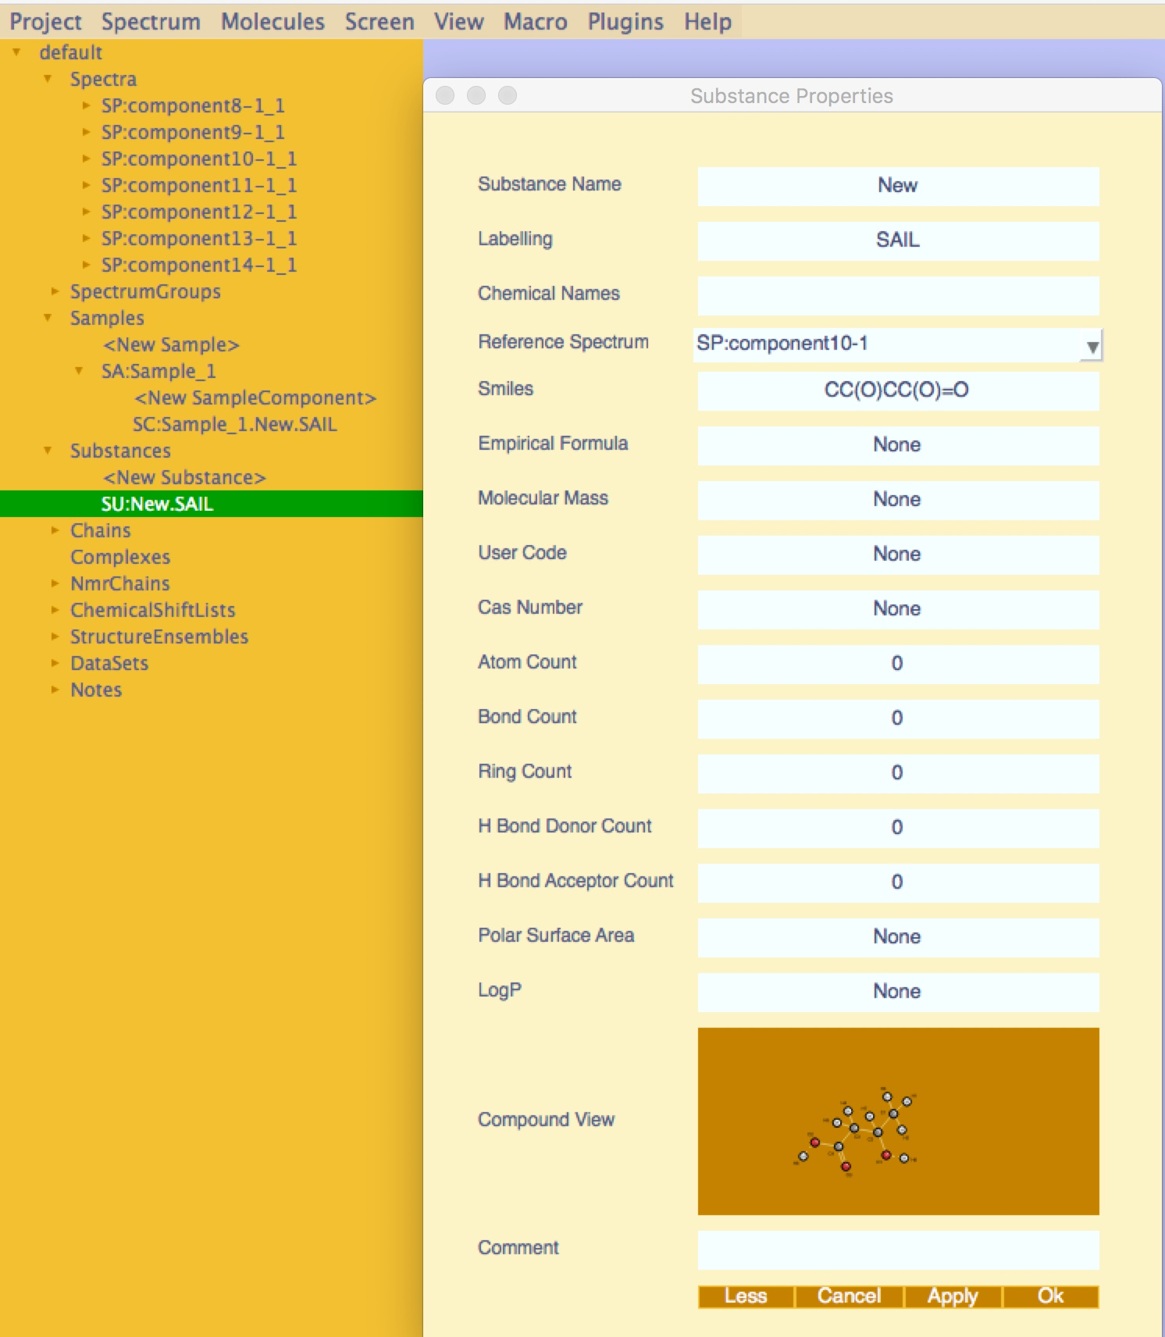

Feature:

Inserting a *Smiles* and clicking the apply button, will instantly generate and show the compound structure.

# 1D Peak Picking

### How to Find 1D Spectra Peaks

Two options available:

* Manual
* Automatic

### Manual Peak Picking

In a new empty project:

1. Drag-and-drop a spectrum into the Blank Display

(You can find One-Dimensional Spectra on: Data/testProjects/AnalysisScreen_Demo1)

1. Move the mouse into a region of the spectrum you want to pick the peaks from.
2. Use the mouse shortcut: CTRL (for Linux)/CMD (for Mac) +SHIFT+LeftButton and drag to start creating the picking box in the display (cyan colour):

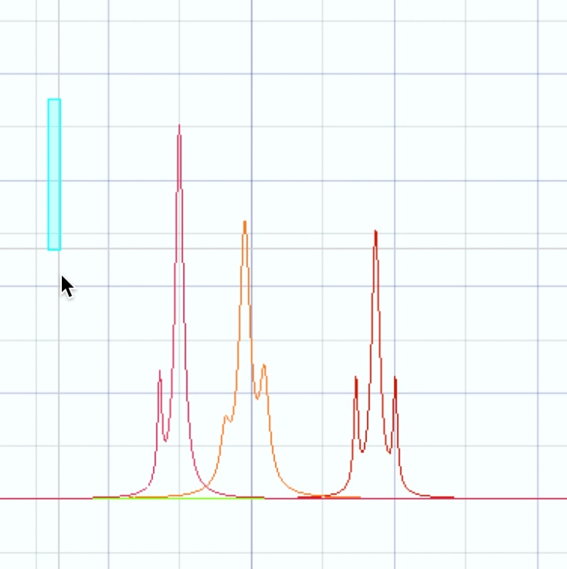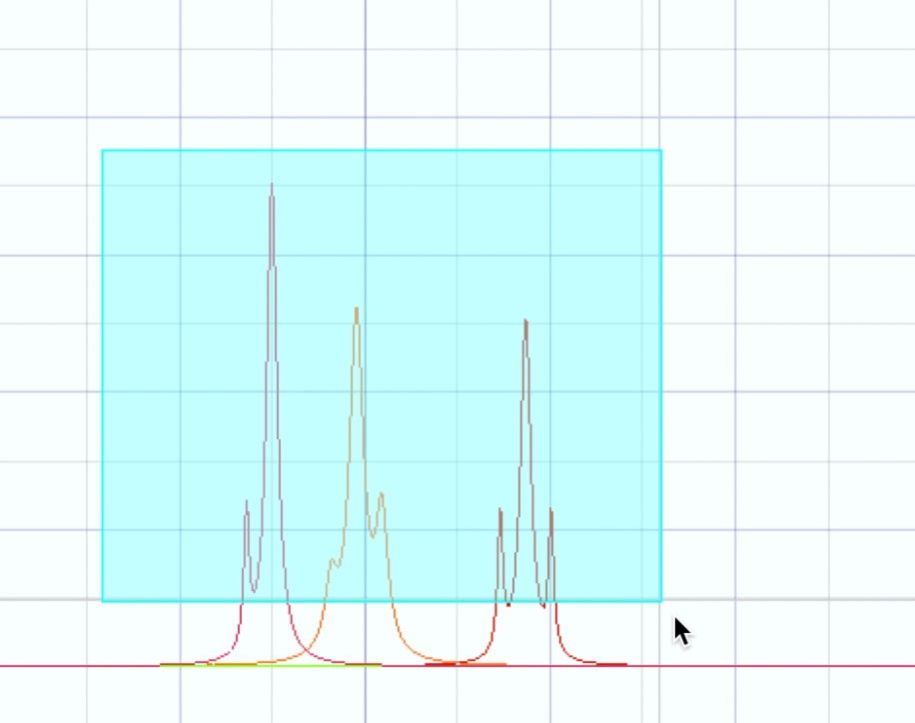

1. Release the mouse button to pick the peaks within the box

NB. You must release the left-mouse-button before letting go of the SHIFT key otherwise nothing will be selected. If this happens, just repeat the action releasing the mouse button first. A series of peaks will now be labelled in the spectrum display:

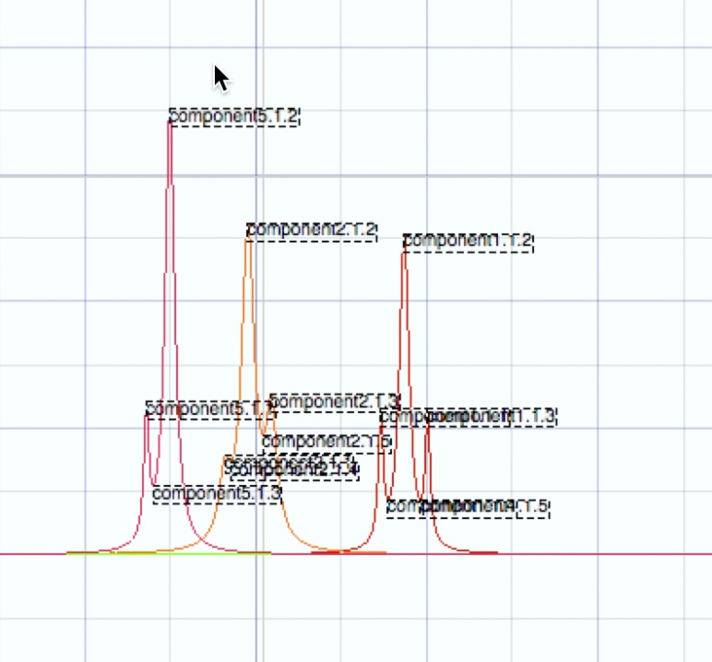

### Automatic Peak Picking

Assuming you have spectra in the project:

1. Go on the menu bar and select: *Spectrum*
2. Followed by: *Pick Peaks*
3. Choose: *Pick 1D Peaks…*

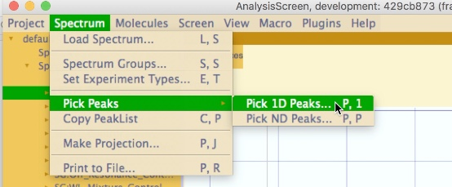

1. The 1D peak picker popup will appear

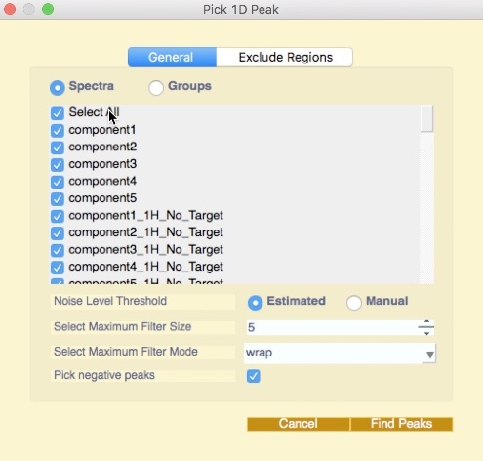 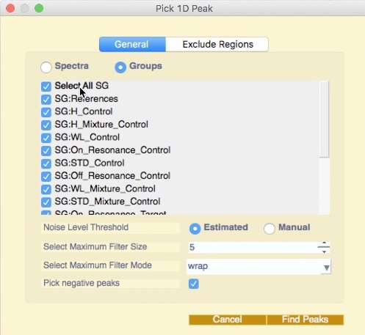

NB. You can get the same popup with the shortcut command “P1”

1. Select the Spectra or the SpectrumGroup you need
2. Leave as default the *Noise Level Threshold* if you have different types of noise across all the spectra you have selected
3. Increase the *Maximum Filter Mode* if you have very noisy spectra or spectra with a large number of “shoulder” peaks
4. Go on the next tab, *Exclude Regions*, to select the region of the spectrum where you don’t want to pick peaks
5. Select the solvent from the list or create your new regions (select *New regions*):

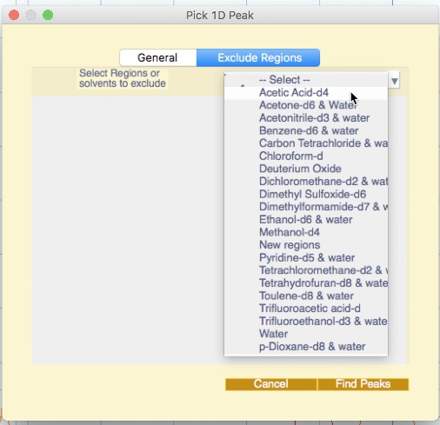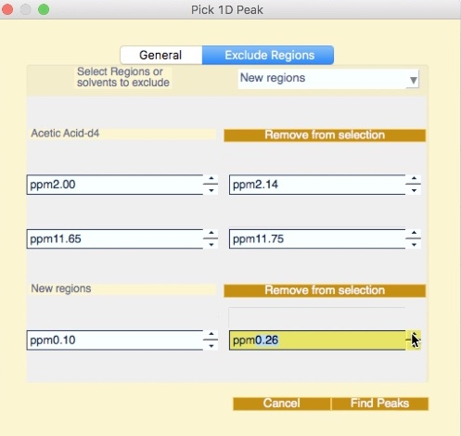

1. Add how many regions you require and/or adjust the values as you need
2. Click the *Find Peaks* button

Another option to automatically pick 1D peaks is by using the Pipeline. This method will allow you to select graphically the regions of the spectrum you want to exclude or set graphically the baseline noise threshold. For further information, see the Pipeline Tutorials.

To visualise the peaks, open a PeakTable (shortcut “L,T”) or from the menu, *View -> Peak Table*, and select the desired PeakList from the pulldown:

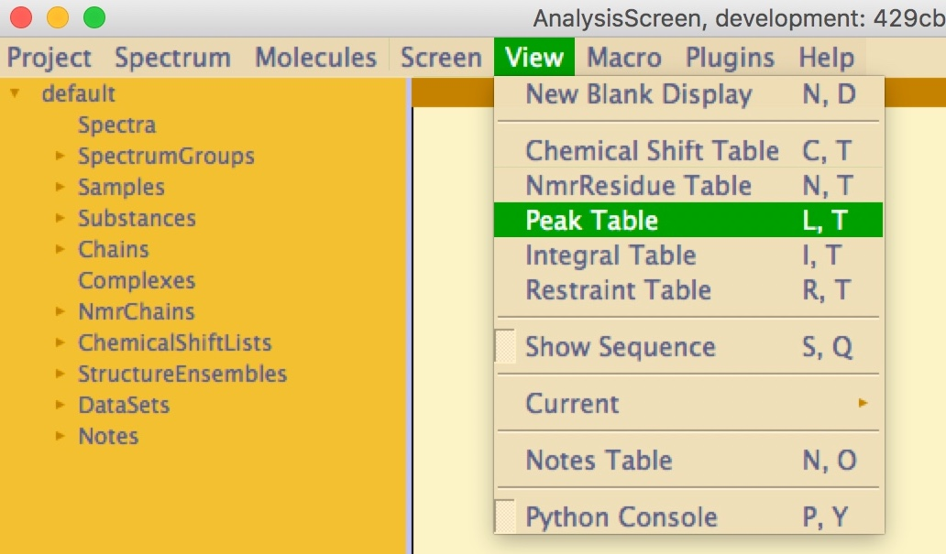

### Deleting 1D Peaks

There are two methods of deleting 1D peaks:

* From the Spectrum Display:

1. Drag-and-drop the spectrum into the Blank Display
2. Move the mouse to a region of the spectrum you want to select the peaks from
3. Use the mouse shortcut: CTRL (for Linux)/CMD (for Mac) +Left drag to start creating the selection box in the display (pink colour):

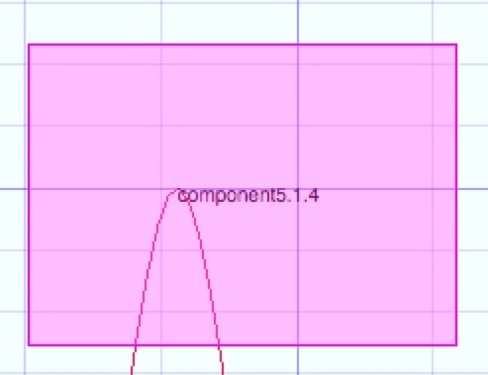

1. Release the mouse button to select the peaks within the box
2. Press the Delete button on your keyboard

* From the Peak Table:
  + 1. Open a new Table (shortcut “L,T”)
    2. Select the Peak List from the selection pulldown
    3. If the peak is already selected on the display, it will be highlighted on the table
    4. Right click on the row, and select *Delete* from the popup menu

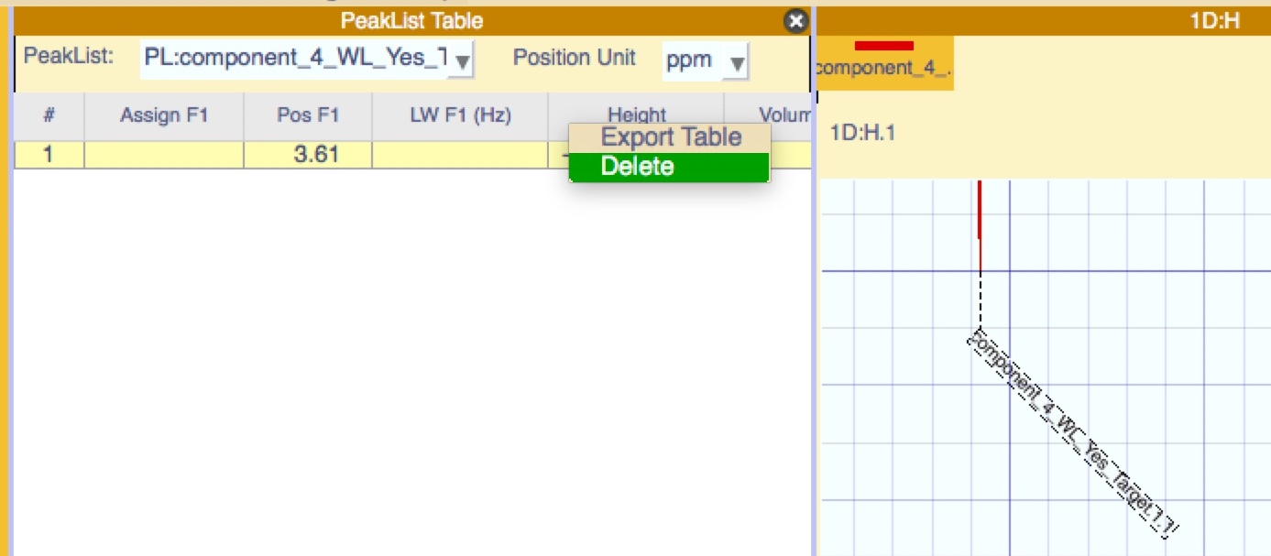

# Mixture calculation

In order to decrease the experimental resources needed in screening by NMR, a

common approach is to analyse several compounds per time against a target. This is often translated into a very crowded spectrum that is difficult to interpret, very error prone and time-consuming.

In this tutorial you will learn how to create cocktails of one dimensional reference spectra with minimal peak overlapping. The new mixtures can be manually analysed and exported in excel, ready to be printed and prepared in the lab.

This tutorial has been written using the Dark CcpNmr colour scheme. If you would like to change colour scheme: *Menu -> Project -> Preferences… -> Colour Scheme*. Save the project and restart.

In this tutorial you will use 20 synthetic spectra, meant to be references of 20 demo small molecules. You will load onto the software using a lookup file.

Locate the lookup file in the directory:

/data/testProjects/AnalysisScreen_Demo1/demoDataset_Lookup

1. Open a new project
2. Drag-and-drop the file *Lookup_Demo.xls* onto the Sidebar
3. Select: *Menu -> Screen ->* Generate Mixtures (or shortcut “C,S”)
4. The *Mixture Generation Setup* popup will appear

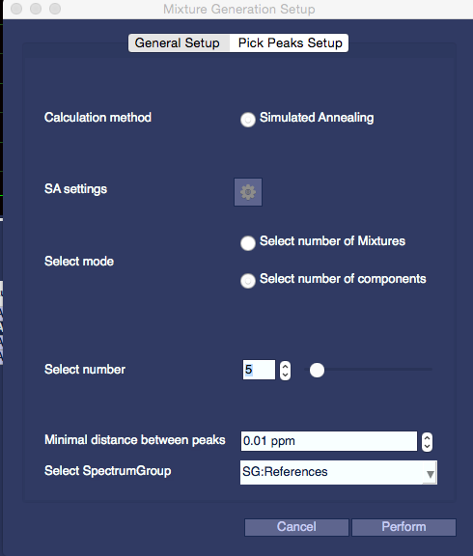

1. The calculation method will be a simulated annealing and the setting parameters are available by clicking the gear icon

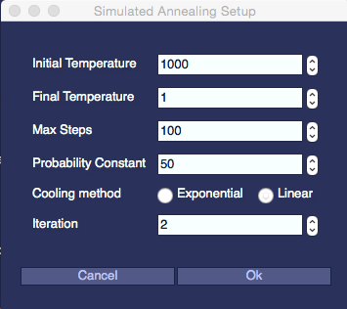

The spectra used in this tutorial are synthetic, with a limited peak count; therefore, leave the default parameters for a quick calculation.

For more crowded spectra, you can increase the *Initial Temperature*, the *Max Steps*, the number of *iterations*, and decrease the *Final Temperature*.

1. Click on *select number of Components* to select how many components you want in each mixture or on *select number of Mixtures*to create exactly that amount of mixtures with equally distributed components.

In the lookup file you loaded are present only 20 reference spectra, therefore select any value between two to 10 in the option *number of Mixtures* or two to 20 in *number of Components* on the slider or on the spin box. Five components per mixture is usually a common choice:

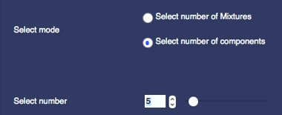

1. Next, select the *minimal distance between peaks,* you may leave the default 0.01ppm. The algorithm will try to return spectra where two adjacent peaks are separated by at least the selected value
2. Select the SpectrumGroup you want to use to create the mixture, in this case: *SG:References*

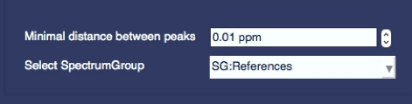

1. On the second Tab*, Pick Peaks Setup*, you can select whether or not to pick the peaks first or use the peaks previously picked. See the 1D Peak Picking tutorial for more details
2. Leave the default values and select the solvent region for Water, by selecting from the solvent pulldown:

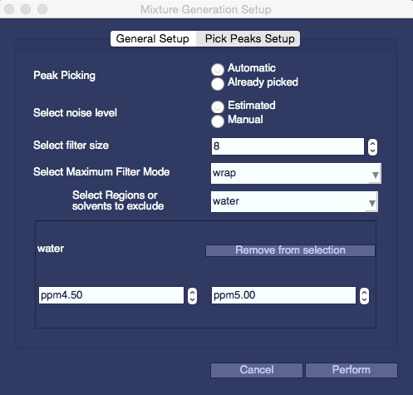

1. Click perform.

### Mixtures Analysis

The module mixture analysis will be opened automatically, if you close it you can reopen from the main menu: -> Screen -> Mixture Analysis (or shortcut “S,T”):

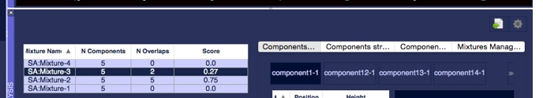

On the left part of module, you have a table with all the scored mixtures.

The distance between the best-resolved peak and its closest neighbour as a penalty value gives the score. The more overlapped the peaks, the higher the score, where a score of 0.0 means no overlapped peaks in the mixture.

On the table you can see how many components are present in each mixture and the total number of overlapped peaks.

The table can be sorted into ascending or descending order by clicking on the table header column.

The full inspection of the mixture can be done in the four tabs on the right part of the module.

1. Select a mixture from the left table.
2. On the first Tab, there is a toolbar containing the spectrum component of each mixture. Click a button to open the relative PeakList. If a substance is linked to the spectrum, the molecule structure will appear on the right side:

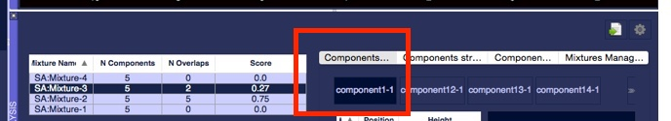

1. Use the tabs *Components Structure* and *Components Info* to visualise extra mixture properties.

The tab *Mixture Management* will allow you to move components across the mixture and try to get better scores manually or create new ones.

1. Select an option on the right Pulldown, e.g., *New empty mixture* or any other mixture. Drag-and-drop the components across the windows and click the *Predict* button to recalculate the scores, then *Apply* to get the new mixtures.

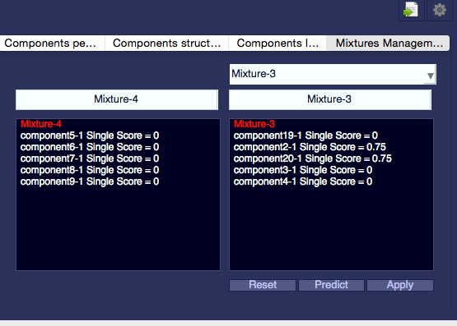

Once you are happy with your mixture you can export it to an excel file using the export button on the top right corner.

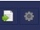

# Pipeline

The Pipeline is the core module of AnalysisScreen. It allows you to apply several tasks or algorithms, called pipes, to single spectra or groups of spectra (SpectrumGroups).

You can run single pipes or a queue of pipes, where the output from each pipe will be the new input for the next pipe.

The pipeline has been built to be a flexible tool, and in this tutorial are shown only few features for One-Dimensional Spectra. There will be more available pipes in next AnalysisScreen updates, including pipes for N-Dimensional spectra.

The Graphical User Interface Module of the Pipeline is shown below (Figure 13), this is opened by selecting menu->Screen->Screening Pipeline, or using the shortcut “S,P”:

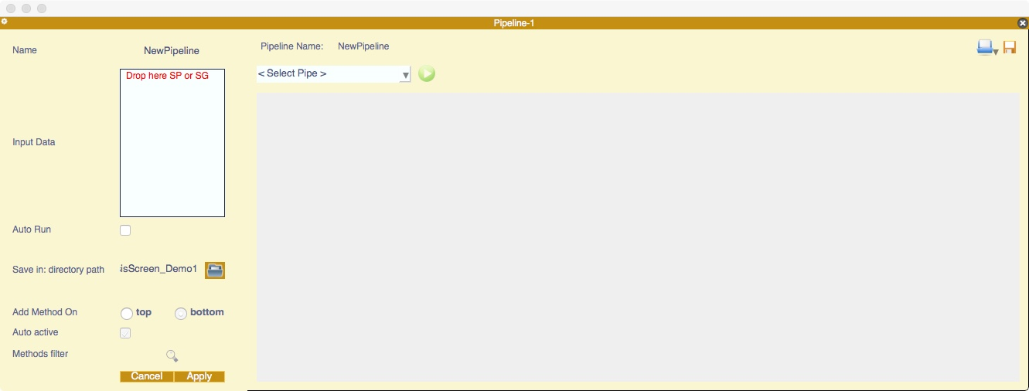

Figure 13

On the left side of the picture is the settings widget:

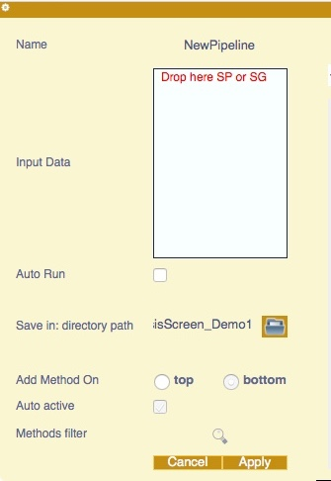

To open the settings section, if not visible, click the gear icon on the top left corner of the module.

In here you can change:

* *Pipeline name*
* *Input Data*: drag-and-drop Spectra or SpectrumGroups from the sidebar in here
* *Auto Run*: (keeps running the same pipeline until you stop - under development)
* *Select the directory path*, where to save the pipeline parameters as JSON file
* *Add Method On*: Select Top to add the new pipe on top of the last pipe. Default is bottom
* *Auto active*: the new pipe can be active or not. If not active the pipe will be skipped in the pipeline queue. You can toggle this on the pipe itself. Default is always active
* *Method filter*: opens a popup where you can select which pipes to display on the main pulldown.

When you open the module, you will find on the main pulldown all the available pipes listed as default.

To change the pipes displayed in the pulldown.

1. Click the Methods Filter button.
2. A popup will open, check or uncheck the pipes you want to see as preferred (on top of the pulldown list):

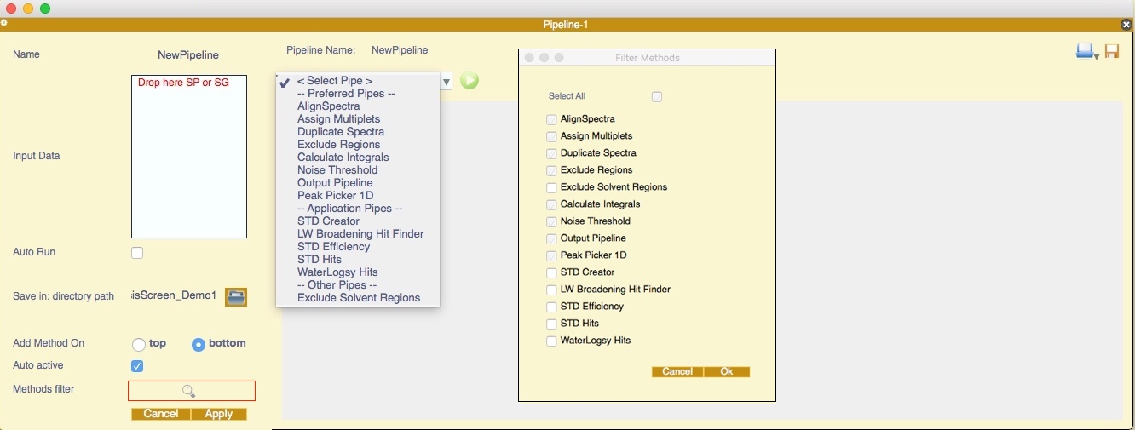

1. Click *Ok,* followed by *Apply* in the settings box

In the following part of the tutorial we will be using the *Lookup_Demo_HDF5* file located in the directory:

/data/testProjects/AnalysisScreen_Demo1/demoDatasetHDF5

The screen pipes use mostly SpectrumGroups. See the *Excel Lookup* *File* tutorial if you need to create a new lookup or *How to create a SpectrumGroup/Sample/Substance* tutorials.

This Pipeline tutorial simulates an experimental analysis of a sample made by five components and containing spectra recorded in three different experiment types.

The tutorial is divided in four parts:

* Part1: Picking References peaks
* Part2: STDs Hit Detection
* Part3: Line Broadening Hit Detection
* Part4: WaterLogsy Hit Detection

### 

### Part 1: Picking References peaks

We will start this experimental analysis picking the references spectra peaks.

1. On a new project, drag-and-drop the *Lookup_Demo_HDF5* into the Sidebar.
2. Find in the Sidebar the Spectrum Group SG:References.
3. Drag-and-drop the item into the Input Data box in the settings and click *Apply*:

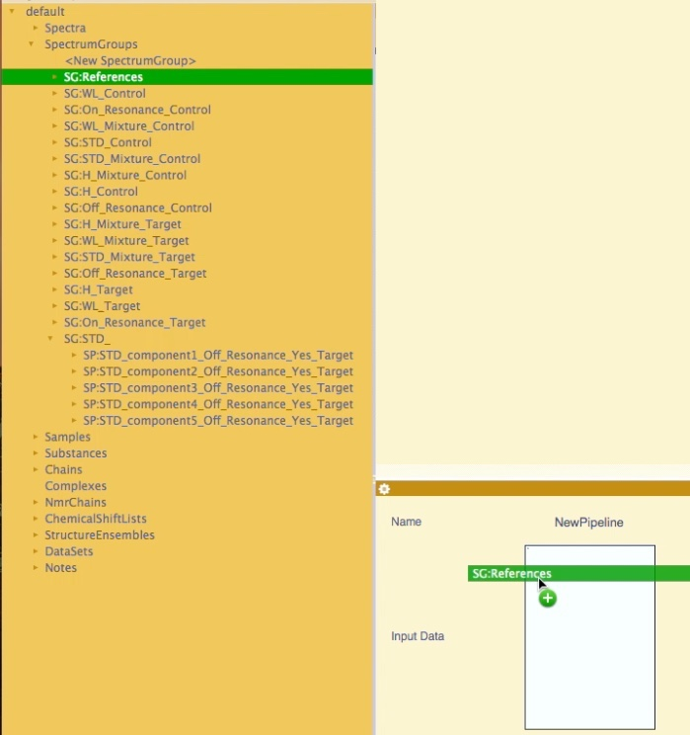

1. Drag and drop the SG:References into a new Blank Display (Click on the Spectrum Display strip if is not set as *Current, denoted by the axis highlighted as green)*
2. If necessary, reorder the modules, so that the Spectrum Display is above the Pipeline:

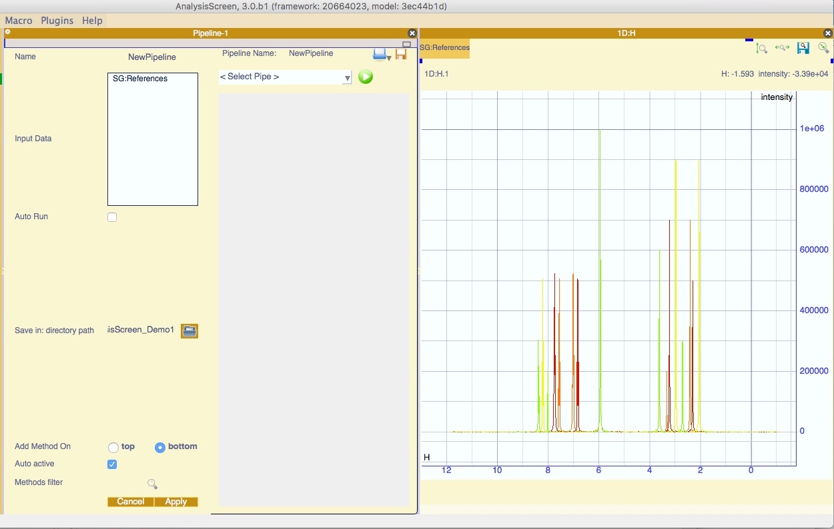 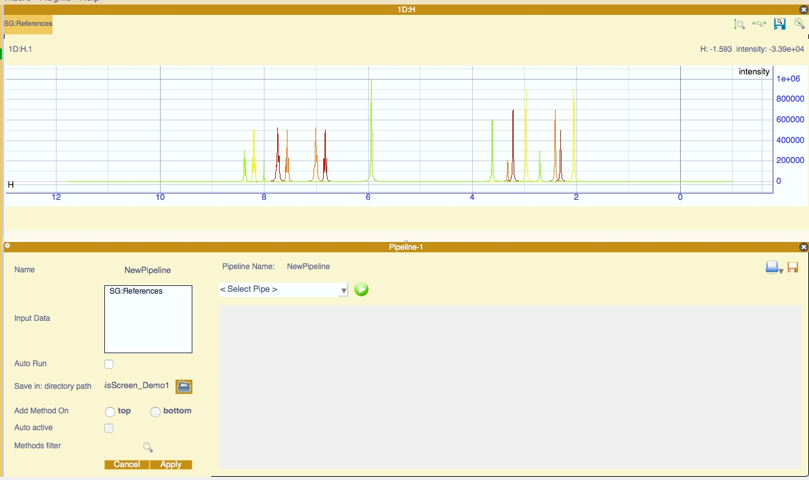

1. Add the Exclude Regions Pipe from the pulldown.
2. Toggle the button immediately to the left of the first spin-box. This will insert into the current strip a rectangle that will define the region to exclude; a vertical line will appear in the spectrum display aligned at zero.
3. Increase the combo boxes values to give the range 0:4ppm to exclude all the first part of the spectrum. Adjust the box by holding the left mouse button and dragging the boundaries of the box or dragging the centre of the box.
4. Add an extra region by pressing the “+” button. Set the range to 5:6.5 ppm:



1. Add the pipe *Noise Threshold*; it works like the previous pipe but drawing a rectangle across the spectrum.
2. Toggle the button to make the box visible and set the range to -10,000:10,000



1. Add the pipe *Peak Picker1D.* Leave the values as default:



You should have a pipeline like shown below:

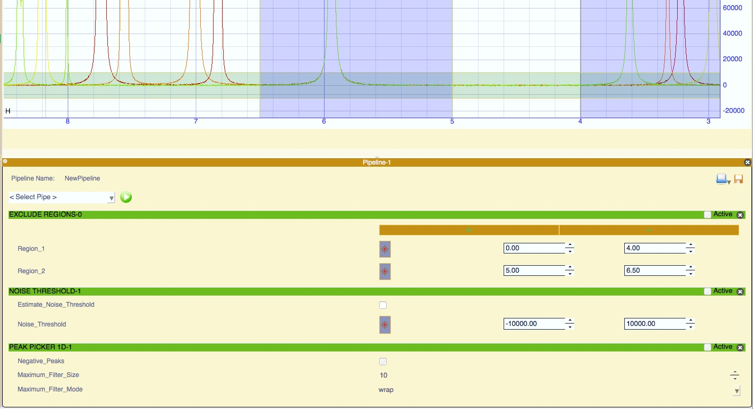

1. Click the green play button.

You have now picked the References Peaks. Keep these pipes opened for the next section.

### Part 2: STDs Hit Detection

*STD creator*

These pipes will allow you to create an STD SpectrumGroup containing all STDs created from On- and Off-resonance SpectrumGroups and calculate the STD peak efficiency.

1. Clear the *Input Data* by right clicking inside the box widget and select *Delete All*.
2. Find in the Sidebar the following SpectrumGroups:

* *SG:On_Resonance_Target*
* *SG:Off_Resonance_Target*

1. Select each, drag-and-drop inside the Input Data box and click *Apply*.

Tip: For multiple selection on the Sidebar:

If two or more items are adjacent: hold “Shift”, click first and last item.

If two or more items are not adjacent: hold “alt+cmd(ctrl)” and click the items individually.

1. Click *Apply* on the settings widget.
2. Add the *STD creator* Pipe and fill in the inputs:

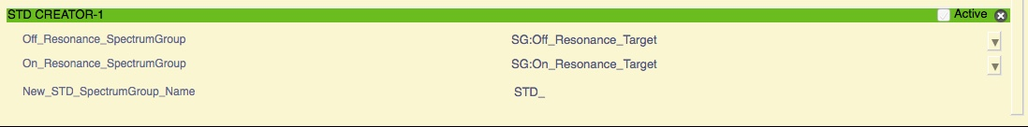

1. Click and hold on the green title bar and drag the pipe to the top of the list. This will put the pipe first on the Pipeline queue.

You should have a pipeline that will look like this:

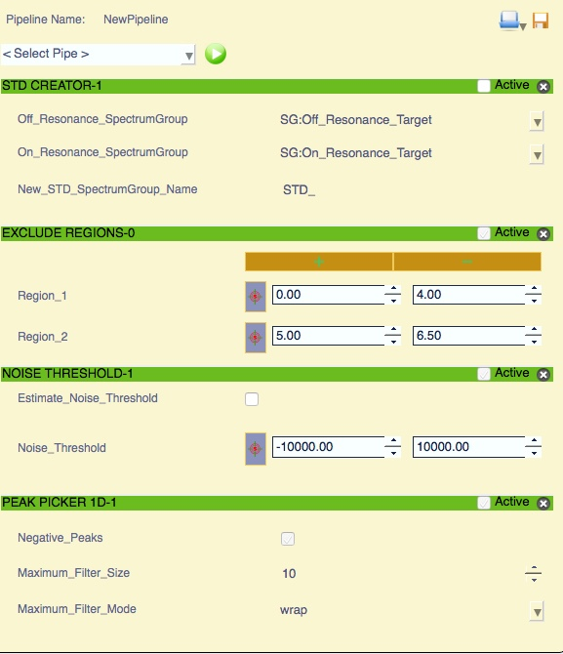

Make sure you selected the correct SpectrumGroups in the selection pulldowns.

1. By clicking play, the pipeline will:
   * Create a new SpectrumGroup called SG:STD_ as default
   * Add it to the pipeline InputData
   * Pick the peaks in all the SpectrumGroups
2. Close all the pipes, keep the pipeline open and keep the SGs (SG:OnResonance_target, SG:OffResonance_Target, SG:STD_) in the *Input Data* box.

Of course you can apply the pipes one-by-one if you are unsure of the STD output noise level *a priori*. This was an example of how you can run the same pipes with different Input Data.

*STD Efficiency*

Now that we have picked the peaks both in the On, Off Resonance and STD spectra, we can calculate the efficiency for each single STD peak:

1. Make sure the input Data box contains:

SG:OnResonance_target, SG:OffResonance_Target, SG:STD_

1. Add the *STD Efficiency* pipe and fill the entries:

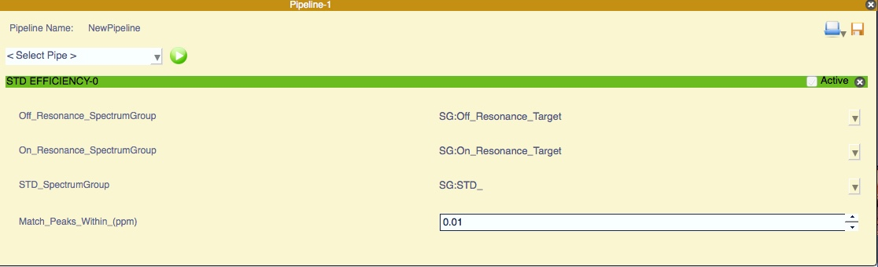

1. Keep *match_peaks_within_(ppm)* as the default of 0.01 ppm.

This will match the On-Off resonance peaks to the STD peak.

1. Check the SGs entries are correct and click the play button.

The STD efficiency is now calculated and stored in the peak object as *Merit*. You will

1. Close the Pipe.

*STD Hit Finder*

1. Add the SG:References (and the SG:STD_ if not there) to the Input Data box and click *Apply*
2. Add the *STD Hits* pipe and select the entries for the SpectrumGroups according to the labels.
3. Keep the other options as default.
4. Check the SGs entries are correct and click the play button.
5. Close the Pipe, clear the input Data box and click Apply.

At this point the software will have found some STD hits and matched them to the reference. Open the Hit Analysis module, select menu->Screen->Hit Analysis, or shortcut “H,A”, to inspect the hits found so far, this is detailed in the following section.

For this particular example, the Samples contained only one SampleComponent each; however, all *Hit Finder* pipes will also work using samples containing multiple SampleComponents (mixtures).

### Part 3: WaterLogsy Hit Detection

In this example we will use samples containing mixtures of components and will let the software find the hits and match them to the relative references.

To detect hits in WaterLogsy experiments simply build the pipeline as follow:

1. Clear Input Data, close all pipes (if any opened).
2. Drag-and-drop the SG:WL_Mixture_Control and SG: WL_Mixture_Target spectrum groups into the Input Data box, click *Apply.*
3. Add the pipes:

* *Exclude Regions*
* *Peak Picker 1D*
* *WaterLogsy Hits*

1. Fill the pipes *Exclude Regions and Peak Picker 1D* as before:

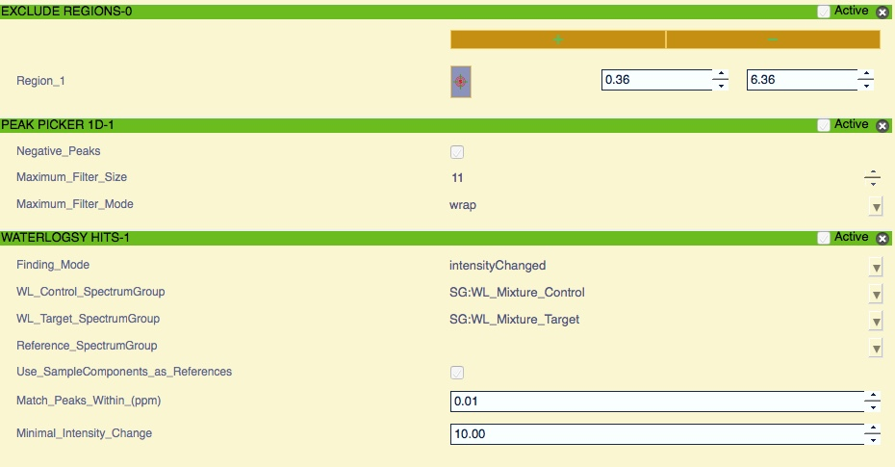

1. The *WaterLogsy Hits* pipe has three detection modes:

* *signChanged*: detects only if there are peaks that changed sign from negative to positive from the WL_Control to the WL_Target spectrum. This is unavailable without a WL_Control spectrum.
* *intensityChanged*: detects the intensity changes of peaks from the WL_Control to the WL_Target spectrum. This is unavailable without a WL_Control spectrum.
* *positiveOnly*: detects only if the intensity peaks of WL_Target are positive. Used if there is no WL_Control spectrum. NB., this method can give false positive hits in the case of aggregation of ligands.

Keep the default setting: *intensityChanged*

1. Check the box *use_SampleComponents_as_references.* This option will use the sampleComponents and linked substance reference spectrum as reference for the hit identification.
2. Leave the rest as default and click the *play* Button.

At this point the software will have found some hits and matched them to the reference. Check the *Hit Analysis* Module to inspect the hits found so far

### Part 4: Line Broadening Hit Detection

To detect hit-by-line broadening of peaks, create the pipeline as follows:

1. Clear Input Data, close all pipes (if any opened).
2. Drag and drop the SG:H_Control, SG: H_Target and SG:References. Click *Apply.*
3. Add the Pipes:

* *Exclude Regions*
* *Peak Picker 1D*
* *Assign Multiplets*
* *LW Broadening Hit Finder*

1. Insert the regions to exclude, you can simply type 0 to 6.5 ppm

In this example, we can skip the *Noise Threshold* pipe, as it will pick the peaks by estimating the Noise Threshold value. Leave the *Peak Picker 1D pipe values* as default.

1. The *Assign Multiplets* pipe will find each NMR multiplet and assign them as if they were single peak. This pipe will create a new peak list for each spectrum in the pipeline. New peaks will get: linewidths, position and intensity.
2. In the *LW Broadening Hit Finder* insert the SpectrumGroups as indicated by labels,

Leave the rest as default.

1. Check the SGs entries are correct in the pulldowns. Click the play button.
2. Close the Pipe.

At this point the software will have found some hits and matched to them to the reference. Open the *Hit Analysis* module to inspect the hits found so far.

.

# Hit Analysis Module

This module will allow you to graphically inspect *SpectrumHits*, the list of spectrum hits that have been found in the previous sections.

Assuming you have found *SpectrumHits*, open the Hit Analysis module from:

*Menu -> Screen ->* Hit Analysis (or shortcut “H,A”)

The module is divided in four section:

* Experiment Type
* *SpectrumHits* table
* *Matched Reference Peak* Table and *Target Peak Hits* Table
* Reference Details

Open a *spectrumDisplay* (drag-and-drop an SG onto a Blank Display) to link the Current Strip to the Hit Analysis Module, e.g., SG:WL_Mixture_Target:

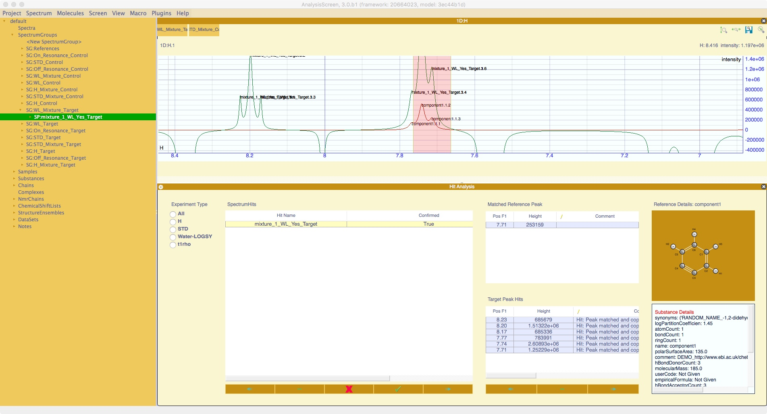

The tables can be filtered by selecting the required Experiment Type from the radio buttons in the first section.

Selecting a hit on *SpectrumHits* table will populate the *Matched Reference Peak* Table and *Target Peak* Table. The two tables are linked; selecting a peak in the *Target Peak* Table will highlight the matched peak in the *Matched Reference Peak* Table. The matched peak is considered the Peak Hit.

If the reference spectrum has a reference Substance, the details will be displayed in the *Reference Details* section.

There is always the possibly that there are false positives in the peak tables. To delete the incorrect target peak, select the row in the *Matched Reference Peak* table or the *Target Peak Hits* table and click the button below: “-“. Either table can be used as the tables are linked.

Similarly, if a *SpectrumHit* appears to be wrong, select the row on the *SpectrumHits* table and click the button below: “-“.

When *SpectrumHits* are calculated, by default they are marked as not confirmed; they are displayed in the Confirmed column as *None*. If you want to change the state, click on the “✓” button to confirm the hit (True), or the “**X**” button to set as not confirmed (False):

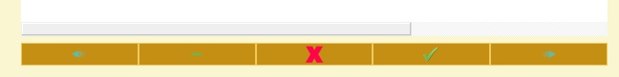

If a spectrum display is opened, by default you will have vertical regions to highlight the peak hit. If you don’t want this feature, open the settings by clicking the settings gear button and uncheck *Show Hit Regions* at the bottom of the list.

If during the peak inspection you want to visualise only few table columns:

1. Right click on the table header
2. Click on Columns Settings…
3. Check/Uncheck as the columns as required

Finally, to save the *SpectrumHits*, open the settings and click the *Export Hits* Button.